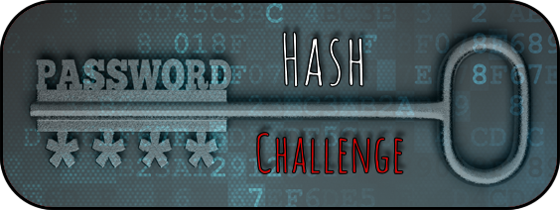

Starter discussion questions?
What are the 10 most commonly used passwords?

What is a hashing algorithm?

Scenario:
A network administrator has access to a database of user details for their own website. Passwords are not stored in plaintext but a hash of each users’ password is stored.
The admin suspects some of the users have weak passwords that are compromising the security of the network.
Your job is to discover which users have weak passwords so that the admin can force them to reset their passwords before their accounts are hacked.

ID | firstname | surname | username | hash
1 | Anthony | Johnson | ajohnson0 | F075E48000CE019587C1953BB925DCCD
2 | Karen | Fisher | kfisher1 | E10ADC3949BA59ABBE56E057F20F883E
3 | Carlos | Williamson | cwilliamson2 | B0F1296F3E4457FB6EBA127F3B5CCA73
4 | Jeffrey | Howell | jhowell3 | 715368C1933E8DD6B8DCB7C6B3D2DBD7
5 | Mildred | Torres | mtorres4 | 5F4DCC3B5AA765D61D8327DEB882CF99
6 | Marilyn | Butler | mbutler5 | 5AD65DDD958F193CC576D8CA6A017BBC
7 | Samuel | Lawrence | slawrence6 | 841981280AF265485B929571466D82F9
8 | Keith | Wells | kwells7 | 35C62F282F9E85AB3E6D7382B3FC72D3
9 | Gregory | Nguyen | gnguyen8 | E75029090B49A3712BFFBC49A623713E
10 | Diana | Gardner | dgardner9 | D8578EDF8458CE06FBC5BB76A58C5CA4

Research and discussion Question
Which users have weak passwords?

Can you tell from the hash alone? Hint – 3 hashes below are the result of using the MD5 hash function on one of the top 5 passwords used in 2017

Notes:

Create a MD5 generator tool in python:
You can generate hashes in python with the hashlib module
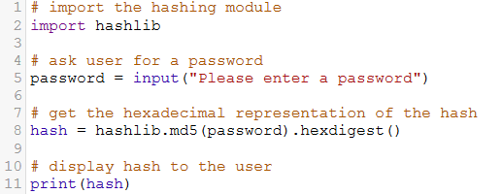

You can find and run a copy of this code here: https://create.withcode.uk/python/Qj

Extension ideas:
- Ask the user to input a salt as well as a password to your MD5 hash for additional security
(HINT – a salt is random data that is used as an additional input to a one-way function that "hashes" data, a password or passphrase)
Hint: If your salt is “1234” and your password is “password”, you’d generate the MD5 hash of “1234password”

- Generate a SHA256 hash as well as a MD5
Hint: Use hashlib.sha256 instead of hashlib.md5

- Generate a SHA512 hash as well as MD5
Hint: Use hashlib.sha512 instead of hashlib.md5

- Write a program that will load a file and generate a MD5 digest of its contents
Hint: http://stackoverflow.com/questions/3431825/generating-an-md5-checksum-of-a-file discusses some different ways to do this

- Each of the following hashes are generated from a password that is a 4 digit numerical pin code. Write a program that will discover the password for any of the hashes below:
ID | firstname | surname | username | hash
1 | Ernest | Reed | ereedk | B8002139CDDE66B87638F7F91D169D96
2 | Peter | Wells | pwellsl | 7EA25C95B0792CA4CE01EA18BBDA2D44
3 | Edward | Martin | emartinm | D39934CE111A864ABF40391F3DA9CDF5
4 | Martin | Weaver | mweavern | 024D2D699E6C1A82C9BA986386F4D824
5 | Jean | Hunter | jhuntero | D77C703536718B95308130FF2E5CF9EE
6 | Catherine | Garza | cgarzap | 67606D48E361CE176CA71FD54FCF4286
7 | Jacqueline | Welch | jwelchq | B29EED44276144E4E8103A661F9A78B7
8 | Joseph | Ramos | jramosr | 109D2DD3608F669CA17920C511C2A41E
9 | Judy | Perry | jperrys | 64D52E08CC03E6090BC1EF30B73CCB85
10 | Antonio | Sanchez | asanchezt | E643B33B3019892367371B27BC0E63C2

Hint: Use a for loop to generate a MD5 hash for each of the 9999 possible pin codes. Check if it matches one of the hashes above.

Note: all user details in this example are randomly generated.

